AGENDAS :
- INTRODUCTION :
- BRIEF HISTORY AND BACKGROUND
- WHY NEURAL NETWORKS ?
- BASIC CONCEPTS OF ARTIFICIAL NEURONS AND NEURAL NETWORKS
- NEURAL NETWORK ARCHITECTURE
- TRAINING AND NEURAL NETWORK ALGORITHMS
- APPLICATION OF NEURAL NETWORKS
- CHALLENGES AND FUTURE DIRECTIONS
- CONCLUSION
- REFERENCES

Can you imagine a computer system that can learn and make decisions like the human brain?
Are you curious about how computers can understand and interpret human speech?
Have you ever wondered how self-driving cars navigate through complex traffic situations
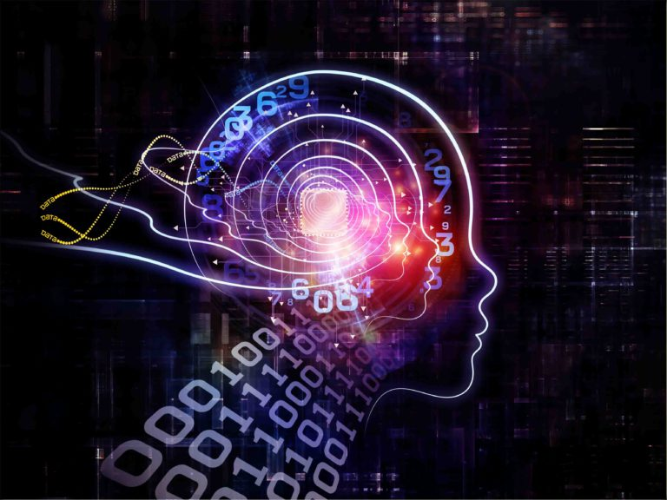
Source : (Jucutan, 2018)
GESTURE PLAN :
- Introduction to Neural Networks
A neural network is a computer system inspired by the human brain that processes information through interconnected nodes.
Brief history and background
According to ( Müller, B., Reinhardt, J. and Strickland, M.T., 1995)
Stage | Date | Development
Early Development | 1940s | Proposal of artificial neurons as models
Perceptron | Late 1950s | Introduction of the Perceptron, an early learning neural network
Limitations and Frustration | 1960s | Highlighted challenges of single-layer perceptrons, decline in interest
Renewed Interest | 1980s | Researchers like Kohonen and Hopfield reignited interest
Backpropagation Algorithm | 1980s | Rediscovery of backpropagation revolutionized training
Modern Advancements | Recent years | Significant progress, attention, funding for further research

  - Why Neural Networks ?
Understanding the Brain: Researchers driven to comprehend human brain principles.
Overcoming Computational Limitations: Need for machines beyond sequential computers.
Focus on Complex Tasks: Surge in neural networks to tackle complex tasks.
Advantages over Traditional Computers: Neural networks excel where traditional computers fall short.
  - Basic concepts of artificial neurons and neural networks :
Historical Development:
A wave of interest in neural networks emerged after the introduction of simplified neurons by McCulloch and Pitts in 1943.
Artificial Neurons:
Artificial neurons, also known as nodes, are the fundamental processing elements of neural networks. They are computational models inspired by natural neurons.
Neural Signal Processing:
Artificial neurons receive input signals through synapses, similar to natural neurons receiving signals through dendrites or membranes.
Activation Threshold:
If the input signals surpass a certain threshold, the artificial neuron is activated and emits an output signal through its axon.
Signal Transmission:
The output signal from one artificial neuron can be transmitted to other neurons through synapses, simulating the interconnected nature of natural neural networks.

- Neural Network Architectures
  - Feedforward Neural Networks (Multilayer Perceptron)
a) Information processing technique
b) Meaningful answers with error-prone or incomplete data
c) Rapid processing for solving real-world problems

  - Recurrent Neural Networks (RNNs)
a) State of the art in time series prediction, system identification, and pattern classification.
b) Modification of multilayered feed-forward network with a context layer.
c) Context layer retains information between observations.

  - Convolutional Neural Networks (CNNs)
a) Used for facial recognition and image processing.
b) Training with a large database of pictures.
c) Sampling layers for evaluations and optimization of models for accurate recognition results.
  - Generative Adversarial Networks (GANs)
a) Learn deep representations without extensive annotated training data.
b) Competitive process involving a pair of networks.
c) Applications include image synthesis, semantic image editing, style transfer, image superresolution, and classification.
  - Radial Basis Function Networks (RBFNs)
a) Three-layer feed-forward network.
b) Linear transfer function for output units.
c) Nonlinear transfer function (often Gaussian) for hidden layer neurons.(Chen, Cowan and Grant, 1991)

- Training and Neural Networks Learning Algorithms
TRAINING :
a) Choosing the number of neurons
b) Regularization methods (dropout, weight decay)
c) Learning rate and convergence considerations
ALGORITHMS :
  - Backpropagation Learning
a) Crucial learning algorithm in neural networks.
b) Computes partial derivatives of the error with respect to each weight.
c) Modifies network weights based on these derivatives.
d) Error decreases towards a local minimum by weighting the negative derivatives.
  - Hebbian Learning
Key idea in connectionism.
Modifies synaptic connections based on activation patterns.
Connection strength increases with repeated stimulation.
Based on Hebb's 1949 theory of Hebbian Learning.
  - Perceptron Learning
Single layer neural network for pattern classification.
Trained to produce correct target vector for given input vector.
Utilizes perceptron learning rule for training.
Well-suited for simple problems in pattern classification.
- Applications of Neural Networks
Recommendation Systems :
Provide content recommendations to users.
Enable automatic personalization to a large user base.
Facial Recognition:
Robust facial recognition in surveillance, authentication, and selective entries.
Convolutional Neural Networks (CNN) process large datasets for accurate recognition results.

Stock Market Prediction:
Neural networks, particularly Multilayer Perceptron (MLP), used for real-time stock market predictions.
MLP models analyze past performances, annual returns, and ratios for accurate predictions.
Social Media Analysis:
Analyze social media user behaviors for competitive analysis and data mining.
MLP models forecast social media trends using factors like user preferences and bookmarked choices.
Aerospace Applications:
Time Delay Neural Networks (TNN), applied in aerospace engineering.
Used for fault diagnosis, auto piloting, control system security, and dynamic simulations.
Defense Systems:
Used for logistics, armed attack analysis, object location, air patrols, maritime patrols, and controlling automated drones.
Convolutional Neural Networks (CNN) utilized for underwater mine detection and image processing.

- Challenges and Future Directions
  - Overfitting and underfitting
Underfitting : Model fails to capture underlying data trend due to insufficient training data.
Overfitting: Model doesn't generalize well to unseen data, capturing noise instead of the underlying trend.
  - Data availability and quality
Data challenge: Neural networks need large amounts of data for accurate learning.
Data availability constraint: Insufficient data for some tasks or domains.

Interpretability and explainability
Interpretability challenge: Lack of understanding of how neural networks process data and make decisions.
Black box nature: Difficulty in comprehending learned features and decision-making process.
Implications for transparency, accountability, and trust in fields like healthcare, finance, and law.
  - Advances in neural network research
Attention Mechanisms:
Enable models to focus on relevant parts of input data for efficiency.
Transformer Models:
Perform well in text production and language translation with parallel processing and capturing long-range dependencies.
Graph Neural Networks (GNNs):
Effective for processing data with complex relational structures, such as social networks and molecular graphs, capturing complex connections between nodes.
  - Potential future applications and impact of neural networks
Integration:
Can be integrated with complementary technologies, such as symbolic functions, to address their weaknesses and achieve better results.
Scaling up complexity:
Technological advancements enable larger and more efficient neural networks with increased processing power and data capacity.

New applications:
Neural networks have the potential to transform industries, improving efficiency, targeting new audiences, and enhancing product development and consumer safety.
Potential obsolescence:
Despite progress, neural networks may face limitations and alternative approaches may emerge as technology evolves to address complex problems.
- CONCLUSION :
Neural networks mimic the human brain and process information through interconnected nodes.
Different network architectures include feedforward, recurrent, convolutional, generative adversarial, and radial basis function networks.
Training algorithms like backpropagation, Hebbian learning, and perceptron learning improve network performance.
Neural networks have diverse applications such as recommendation systems, facial recognition, stock market prediction, social media analysis, aerospace, and defense.
Challenges include overfitting, data availability, interpretability, and advancements like attention mechanisms and graph neural networks.

REFERENCES :
-Gurney, K., 1997. An introduction to neural networks. CRC press.

-Jucutan, K. (2018). Artificial Neural Network: The Brain Behind Today’s Smart Technology - Coding Dojo Blog. [online] Coding Dojo Blog. Available at: https://www.codingdojo.com/blog/artificial-neural-network-brain-behind-todays-smart-technology.

1) Macukow, B., 2016. Neural networks–state of art, brief history, basic models and architecture. In Computer Information Systems and Industrial Management: 15th IFIP TC8 International Conference, CISIM 2016, Vilnius, Lithuania, September 14-16, 2016, Proceedings 15 (pp. 3-14). Springer International Publishing.

2) Müller, B., Reinhardt, J. and Strickland, M.T., 1995. Neural networks: an introduction. Springer Science & Business Media.

3) Abraham, A., 2005. Artificial neural networks. Handbook of measuring system design.

4) Gershenson, C., 2003. Artificial neural networks for beginners. arXiv preprint cs/0308031.

5) Kaushik, V. (2021). 8 Applications of Neural Networks | Analytics Steps. [online] www.analyticssteps.com. Available at: https://www.analyticssteps.com/blogs/8-applications-neural-networks.

6) Benardos, P.G. and Vosniakos, G.C., 2007. Optimizing feedforward artificial neural network architecture. Engineering applications of artificial intelligence, 20(3), pp.365-382.

7) Creswell, A., White, T., Dumoulin, V., Arulkumaran, K., Sengupta, B. and Bharath, A.A., 2018. Generative adversarial networks: An overview. IEEE signal processing magazine, 35(1), pp.53-65.

8) Sze, V., Chen, Y.H., Yang, T.J. and Emer, J.S., 2017. Efficient processing of deep neural networks: A tutorial and survey. Proceedings of the IEEE, 105(12), pp.2295-2329.

9) GeeksforGeeks. (2023). Advantages and Disadvantages of Deep Learning. [online] Available at: https://www.geeksforgeeks.org/advantages-and-disadvantages-of-deep-learning/.

10) IBM Developer. (n.d.). Deep learning architectures. [online] Available at: https://developer.ibm.com/articles/cc-machine-learning-deep-learning-architectures/.

11) Wang, S., Nepal, S., Rudolph, C., Grobler, M., Chen, S. and Chen, T., 2020. Backdoor attacks against transfer learning with pre-trained deep learning models. IEEE Transactions on Services Computing, 15(3), pp.1526-1539.

12) Arulkumaran, K., Deisenroth, M.P., Brundage, M. and Bharath, A.A., 2017. Deep reinforcement learning: A brief survey. IEEE Signal Processing Magazine, 34(6), pp.26-38.

13) Lotfinejad, M. (2023). Deep Learning Applications.

14) Potential, challenges and future directions for deep learning in prognostics and health management applications’ 2020, Engineering Applications of Artificial Intelligence, vol. 92, p. 103678

15) www.linkedin.com. (n.d.). What are the current challenges and limitations of neural networks and deep learning? [online] Available at: https://www.linkedin.com/advice/3/what-current-challenges-limitations-neural#:~:text=One%20of%20the%20main%20challenges [Accessed 24 Jun. 2023].

16) ReadWrite. (2019). Everything You Need to Know About the Future of Neural Networks. [online] Available at: https://readwrite.com/everything-you-need-to-know-about-the-future-of-neural-networks/.

